 | 10th International Conference on Short and Medium Span Bridges  Quebec City, Quebec, Canada,  July 31 – August 3, 2018 | 

EARLY AGE THERMAL EXPANSION OF STAINLESS-STEEL

REINFORCED-CONCRETE SECTIONS

Youssef, Maged A.^{1,4}, Khalifa, Mokhtar A. ² and Alhadid, Monir M.³
¹ Western University, Canada
² Western University, Canada
³ Western University, Canada
⁴ youssef@uwo.ca
Abstract: In the past 20 years, using stainless steel (SS) bars in construction has gained popularity due to its remarkable capability to overcome corrosion problems. However, the higher thermal expansion of SS bars relative to concrete may cause premature cracking at early age due to temperature rise caused by heat of hydration. This paper provides a description of the influence of thermal incompatibility between SS bars and concrete on crack formation in concrete blocks. A finite element model is developed and validated to predict the radial expansion of SS bars in concrete sections. The procedure commences by performing thermal analysis on various RC sections to determine temperature distribution within them due to heat of hydration. Then, a structural model is developed to determine the induced stresses caused by the incompatibility in radial thermal expansion between SS bars and the surrounding concrete. The outcomes of this study provide a better understanding of the thermal radial expansion of SS bars used in reinforced concrete (RC) members.

1 INTRODUCTION
The use of Austenitic SS rebars in construction became familiar to engineers due to their outstanding properties in preventing the deterioration of RC members caused by corrosion. The presence of chromium in stainless steel results in the formation of a chromium oxide layer, which protects the rebar from being corroded. Thus, stainless steel rebars can tolerate up to 7% chloride level without rusting as opposed to carbon steel, which starts to rust after reaching 0.4% chloride level.

In the current practice, stainless steel rebars are used to reinforce concrete members that are exposed to severe environmental conditions. Typical examples include highway bridges exposed to corrosive substances, coastal structures and parking structures. Also, due to their non-magnetic characteristics, austenitic stainless steel rebars are extensively used in specific applications such as the Magnetic Resonance Imaging (MRI) chambers in hospitals. Furthermore, stainless steel reinforcement is considered as an excellent alternative when retrofitting historical buildings and monuments.
Concrete and carbon steel rebars have similar thermal properties, which make the two materials thermally consistent. On the other hand, the coefficient of thermal expansion of austenitic stainless steel is about 80% higher than that of concrete (CISC 2016, CSA 2014). Thermal incompatibility results in stresses that are not experienced by conventional RC structures. After casting the concrete, the highly exothermic hydration reaction generates heat and resulting in an increase in concrete temperature to about 80ºC after 36 hours (Nanayyakkara 2015). Typical variation of the heat of hydration with time is given in Fig. 1 for normal strength concrete (Byfors 1980, Mindess and Young 1981). Curing has a significant role in controlling the temperature and affecting the mechanical properties of concrete (Kosmalka et al. 2002). A good structural performance of RC members is acquired by ensuring that both concrete and the embedded reinforcing bars possess similar thermal properties. The coefficient of thermal expansion of both concrete and carbon steel rebars are 1.1 ×10^{-5 o}C⁻¹ and 1.2 ×10^{-5 o}C⁻¹, respectively (Nürnberger 2005). These close values imply an excellent thermal compatibility between the two materials. However, thermal expansion coefficient of stainless steel rebars can exceed 1.8 ×10^{-5 o}C⁻¹ (Nürnberger 2005). This relatively larger divergence from concrete thermal expansion raises concerns about the possibility of inducing additional thermal stresses in both concrete and reinforcement that may cause cracks in concrete. Such cracks are undesirable as they can affect the durability of the structure. This scenario may be encountered if the member is subjected to the high temperature caused by the heat of hydration.

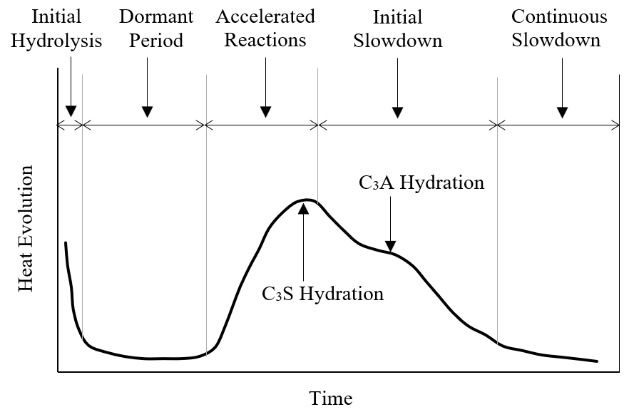
Figure 1: Evolution of Heat of Hydration as a Function of Time

This paper aims at numerically investigating the influence of heat of hydration on crack formation and propagation in stainless steel RC sections considering the thermal incompatibility between the two materials. A finite element model is developed to examine the temperature distribution and stress propagation that may cause cracks. Water curing regime is considered in the analysis to investigate its effect on the crack formation.

2 MATERIAL MODELS
Figures 2(a) and 2(b) illustrate typical variations of concrete compressive strength (f_{c}) and concrete tensile strength (f_{t}) with time, respectively (Jin et al. 2005). The figures show that rate of strength gain has a maximum value during the first week beyond which it decreases considerably. Therefore, the critical time is during the first 1 to 3 days when the temperature due to hydration is at its peak and the concrete strength is small.
- Concrete Compressive Stress, f_{c} | - Concrete Tensile Stress, f_{t}
Figure 2: Variation of Concrete Strength with Time

The normalized compressive stress-strain relationship at various concrete ages is shown in Fig. 3(a). The constitutive relationship is obtained from an extensive experimental study performed by Jin et al. (2005) on normal strength concrete. The figure shows that during the first 7 days, concrete compressive strength increases with time whereas its ductility decreases. The actual curves are considered as inputs in the developed finite element model. For instance, the actual stress-strain curve for concrete at 2 days is shown in Fig. 3(b). The tensile behavior of concrete is predominantly brittle. It is assumed to carry tensile stresses up to the cracking point beyond which the tensile capacity of concrete drops to zero. Concrete thermal properties are assumed as follows: Coefficient of thermal expansion: 10⁻⁵ °C⁻¹(CSA 2014), specific heat: 920 J/kg.°C (ACI 1994) and density: 2300 kg/m³ (EN 1992). The thermal conductivity is assumed to follow the values provided by EC2 (EN 1992) as shown in Fig. 4.

(a) Normalized Curved at Different Ages | (b) Actual Stress-Strain Curve at 2 Days

Figure 3: Normalized Stress-Strain Curves of Concrete at Early Age

Figure 4: Thermal Conductivity for Concrete at Different Temperatures

Stainless steel bars are modelled assuming a modulus of elasticity of 200,000 MPa (CSA 2014) and their thermal properties are assumed as follows: coefficient of thermal expansion of 17.8x10⁻⁶ °C⁻¹, density of 7750 kg/m³, specific heat of 440 J/kg.°C (Nürnberger 2005), and thermal conductivity of 15 w/m.°C (Soudki et al. 2004). The constitutive relationship of the stainless steel rebars is considered based on the experimental work reported by (Chen and Young 2006).

3 PROPOSED FINITE ELEMENT (FE) MODEL
A finite element model is developed to simulate the crack propagation in SS RC blocks at early ages due to temperature increase caused by the hydration reaction. The time-dependent constitutive relationships, mechanical properties and thermal coefficients of both materials are obtained from relevant experimental data to enhance the accuracy of the developed model.

Figure 5 shows a typical cross-section of the RC block considered in the analysis. The examined parameters are the section height (h), section width (b), concrete cover (c) and rebar diameter (d). All sections consist of four stainless-steel rebars placed symmetrically at the corners of the concrete section.
A two-dimensional coupled thermal/structural analysis is performed using ANSYS 17.2 Finite Element Software (ANSYS 2009). Since the section is doubly symmetric about its principal axes in terms of both its geometry and the applied load, only the bottom left quarter is considered in the model. The analysis is performed by selecting appropriate coupled-field elements, specifying thermal and structural material properties, performing thermal analysis to determine the temperature due to heat of hydration at a specific time, and performing a static structural analysis to determine the induced stresses and crack propagation within the section.
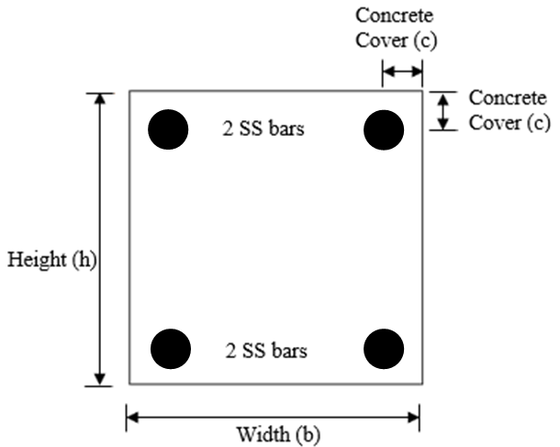
Figure 5: Typical Section of the Stainless-Steel Reinforced Concrete Block

3.1 Thermal Analysis

Both concrete and steel are modeled using PLANE77 two-dimensional 8-node thermal solid element. The selected element is applicable to performing two dimensional steady-state analyses and is characterized of having compatible temperature shapes that are well-suited to model curved geometries, such as the boundary between the concrete matrix and the embedded bars. The boundary between the two materials is modeled using SURF151 and CONTA171, which are applicable to 2D thermal analysis. A typical meshed section is shown in Fig. 6.
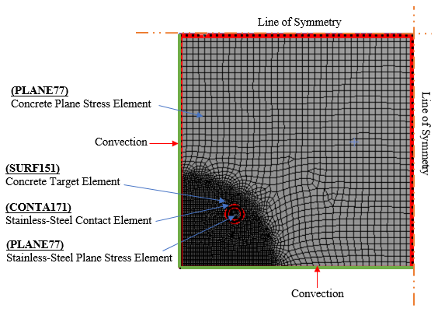
Figure 6: Mesh of the Thermal Analysis

The optimum mesh density is chosen by performing a preliminary sensitivity analysis on the section to reduce the run time while maintaining accurate results. Two methods to perform the analysis are followed. The first one is by refining the mesh until the principal stresses in specific locations converge and do not exhibit significant variation with the subsequent refinements. The other considered method is selecting a mesh density to ensure that the average stress calculated at each node is close in magnitude to the unaveraged stresses obtained from corresponding adjacent elements. In addition to that, the quality of the model and the accuracy of the results are further enhanced by refining the mesh near the stainless-steel rebars, where stress concentration prevails.

The relationship between total heat liberated during the hydration reaction and time at various water/cement ratios was determined in a previous experimental investigation (Rilem 1981). This relationship is considered in the proposed model as an input to specify the thermal load at concrete early age. Fig. 7 illustrates the thermal load curve considered in the proposed model assuming a water/cement ratio of 0.4, which ensures the availability of sufficient water for complete hydration to take place (Rilem 1981). Heat generation is modelled as a time-dependent uniform internal energy that is continuously released from the concrete elements. Heat transfer from the exterior sides of the concrete block due to curing is also considered in the model. Water curing is considered in the analysis by applying heat energy on the exposed boundaries assuming convection coefficients of 12 kcal/m².hr.°C (KCI 2003).

Figure 7: Accumulated Energy due to Heat of Hydration at Different Ages

3.2 Structural Analysis Model

A typical density and configuration of the mesh used in the structural analysis is illustrated in Fig. 8. A static structural analysis is performed by replacing the thermal 2D element (PLANE77) used in thermal analysis with an equivalent structural element (PLANE183) to model both concrete and stainless-steel rebars. This high order 8-node element possesses quadratic displacement behavior with two translational degrees of freedom at each node. This feature allows the element to capture the stress distribution and body distortion with better accuracy. The reinforced concrete section is supported as indicated in Fig. 8. The nodes along both lines of symmetry are restrained against orthogonal translational movement; whereas, the nodes along the free edges are unrestrained. Thermal load is applied to the reinforced concrete section by assigning the concrete elements the temperature values that were reached in the thermal analysis stage.
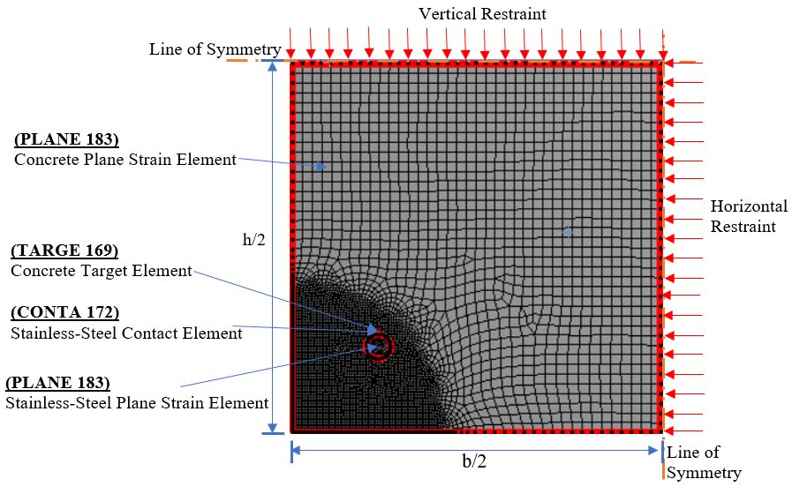
Figure 8: Structural Finite Element Model

The contact between concrete and the boundaries of the steel rebars is simulated by (CONTA172) and the associated target element (TARGE169). These elements are compatible with the 2D coupled analysis and capable of capturing the deformations along the boundaries. Concrete is considered as the target element since it represents the confining material, which counteracts the expansion tendency of the stainless-steel rebars.

4 VALIDATION
The current literature lacks experimental data related to the effect of thermal incompatibility between stainless-steel rebars and concrete on crack propagation at early age. However, in a study with similar scope, Du et al. (2006) conducted finite element analysis to determine the influence of conventional steel rebars’ radial expansion caused by corrosion on the structural response and cracking behavior of concrete elements. The results revealed that radial expansion of the embedded rebars has a remarkable role in crack formation by inducing internal stresses. Crack propagation follows a sequence of stages defined as internal cracking, external cracking, penetration cracking and ultimate cracking. The proposed model is validated in view of the experimental results obtained by Clark and Saifullah (1993) and modelled numerically by Du et al. (2006) the variation of radial expansion with the ratio of concrete cover to rebar diameter (c/d) is determined and compared to the experimental results as illustrated in Fig. 9. The differences in predictions between the two models range between 9% and just under 14%. Such variations are considered acceptable given the complexity of the problem.

Figure 9: Radial Expansion at Various c/d Ratios

5 HEAT OF HYDRATION CASE STUDY
The stress distribution, crack propagation and effect of curing method are examined in view of a 300 mm x 300 mm section reinforced with 10 mm (diameter stainless-steel rebars. The concrete cover, concrete tensile strength and concrete compressive strength are assumed as 35 mm, 2.5 MPa, and 30 MPa, respectively. The section is modeled using 5,678 elements with sizes that vary between 0.85 mm and 4.0 mm. Boundary conditions and heat of hydration are applied as discussed in Section 3 of this paper.

Temperature at a point located in the center of the considered reinforced concrete section considering water curing regime reaches 74.5 C after 2 days. The variation of concrete principal tensile stresses considering water curing regime is shown in Fig. 10. The continuous increase in concrete tensile strength is attributed to the continuous hydration reaction taking place at the early age of concrete. The values of the principal tensile stress keep increasing until reaching a peak and then they decrease gradually over a longer duration. This behavior follows the trend of the temperature distribution within the cross-section caused by the hydration reaction. As the temperature increases, thermal expansion in the stainless-steel rebars increases in a higher rate than the surrounding concrete. This results in the generation of higher thermal stresses. Cracks are considered to form when the principal stresses exceed the tensile strength of concrete. The maximum principal tensile stresses exceed the modulus of rupture of concrete and the maximum principal compressive stresses within the stainless-steel rebars reaches 109.25 MPa after 2 days because of the high temperature reached within the cross-section. The radial expansion of the stainless-steel rebars considering water curing regime reaches 0.00697 mm.
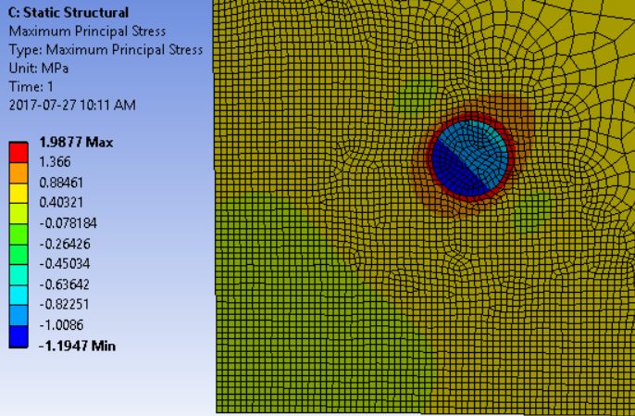

Figure 10: Principal Stress Contours after 2 Days

6 CONCLUSIONS
The variation in thermal expansion between concrete and stainless-steel rebars results in the development of thermal stresses near the rebars causing cracks in concrete cover. Radial thermal expansion of stainless-steel rebars is affected by the temperature generated from the hydration reaction in the surrounding concrete. This expansion is restrained by the concrete matrix and generates thermal stresses near the steel rebars. During the first two days, concrete strength is relatively small whereas the generated stresses are at their peak. This may result in the formation of thermal cracks near the stainless-steel bars. Therefore, minimizing the temperature is important to control the radial expansion of stainless-steel rebars, especially within the first two days of casting the concrete. To control cracking, concrete temperature has to be continuously monitored and controlled. Continuous water curing of concrete reduces the principal stresses and consequently can eliminate the formation of the cracks.

Acknowledgement
This research was funded by the Ontario Ministry of Transportation (MTO).

References

ACI Committee 207. 1994. Mass Concrete. ACI Manual of Concrete Practice, Part 1.
ANSYS. 2009. User’s Manual Release 12.0.1, Canonsburg, Pennsylvania, USA.
Baddoo, N.R. 2008. Stainless Steel in Construction: A Review of Research, Applications, Challenge and Opportunities. Journal of Constructional Steel Research, Elsevier, 64(11): 1199-1206.
Byfors, J. 1980. Plain Concrete at Early Ages. Stockholm: Swedish Cement and Concrete Research Institute.
Chen, J. and Young, B. 2006. Stress–Strain Curves for Stainless Steel at Elevated Temperatures. Engineering Structures, Elsevier, 28(2): 229- 239.
CISC. 2016. Handbook of Steel Construction. 11th ed. Canadian Institute of Steel Construction, Markham, Canada.
Clark, L.A. and Saifullah, M. 1993. Effect of Corrosion on Reinforcement Bond Strength. Proceedings of 5th International Conference on Structural Faults and Repairs, Engineering Technical Press, Edinburgh, 3: 113-119.
CSA A23.3. 2014. Design of Concrete Structures. Cement Association of Canada, Ottawa, Canada.
Du, Y.G., Chan, A.H.C. and Clark. L.A. 2006. Finite Element Analysis of the Effects of Radial Expansion of Corroded Reinforcement. Computers and Structures, Elsevier, 84(13-14): 917-929.
EN 1992-1-2. 2004. Eurocode 2: Design of Concrete Structures - Part 1-2: General Rules – Structural Fire Design, European Committee for Standardization, EU.
Jin, X., Shen, Y. and Li, Z. 2005. Behaviour of High- and Normal-Strength Concrete at Early Ages. Magazine of Concrete Research, ICE Virtual Library, 57(6): 339-345.
KCI. 2003. Standard Specification for Concrete. Korea Concrete Institute, Seoul, Korea.
Kim, T. 2008. Concrete Maturity Method Using Variable Temperature Curing for Normal-Strength Concrete Mixes. Journal of Materials in Civil Engineering, ASCE, Technical Paper, 20(12).
Kosmatka, S.H., Kerkhoff, B. and Panarese, W.C. 2002. Design and Control of Concrete Mixtures. 14th ed., Portland Cement Association, Skokie, Illionis, USA. P47-P49.
Mindess, S. and Young, J.F. 1981. Concrete. 1st ed., Prentice-Hall, Englewood Cliffs, NJ, USA.
Nürnberger, U. 2005. Stainless Steel in Concrete Structures. Corrosion in Reinforced Concrete Structures, Woodhead Publishing Ltd., Cambridge, pp 135-162.
Rilem TC 42-CEA. 1981, Properties of Set Concrete at Early Ages State-of-the-Art-Report. Matériaux et Constructions, 14(84).
Soudki, K.A., West, J.S. and Campbell, T.I. 2004. Effect of Temperature on Structural Performance of Stainless Steel Reinforcement. University of Waterloo. pp.4-5.

